Daily Menu for weeks of September 10th & September 17th
 | MONDAY  9/24 | TUESDAY  9/25 | WEDNESDAY  9/26 | THURSDAY  9/27 | FRIDAY  9/28
AM Snack: | Whole Grain Cheese Toast, Fruit & Milk | Whole Grain Blueberry Muffin, Fruit & Milk | Pancake, Fruit & Milk | Fruit Filled Yogurt, Graham Crackers & Milk | Whole Grain Cereal, Fruit & Milk

Lunch: | Baked Popcorn Chicken, Sweet Potato Tots, Fruit & Milk | BBQ Meatballs, Homestyle Mashed Potatoes, Steamed Vegetables, Hawaiian Roll, Fruit & Milk | Chicken Salad, Tossed Salad, Flatbread Slices, Fruit & Milk | Turkey & Cheese Sandwich, Avocado Slices, Fruit & Milk  Tam-vacation | Pepperoni, Cheese Pizza, Carrots w/ Ranch, Fruit & Milk  Tam-vacation

PM Snack: | Fresh Baked Oatmeal Raisin Cookie & Milk | Pirates Booty & Milk | Cheddar Cheese, Saltines & Water | Mini Nilla Wafers & Milk | Fig Newton Bar, & Milk

 | MONDAY  10/1 | TUESDAY  10/2 | WEDNESDAY  10/3 | THURSDAY  10/4 | FRIDAY  10/5
AM Snack: | Fruit Smoothie, Graham Crackers & Milk | Buttered Biscuit, Fruit & Milk | Waffles, Fruit & Milk | Bran Muffin, Fruit & Milk | Whole Grain Cold Cereal, Fruit & Milk

Lunch: | Grilled Cheese Sandwich, Steamed Vegetables, Fruit & Milk | Egg Casserole w/ Spinach, Sausage, Potato Pancakes, Fruit, Banana Bread & Milk | Pasta Salad w/ Chicken & Fresh Vegetables, Fruit & Milk | Crispy Baked Chicken, Broccoli & Rice Casserole, Fruit & Milk | Fish Sandwich w/Bun, Potato Wedges, Fruit & Milk

PM Snack: | Animal Crackers & Milk | Pretzels, Raisins & Water | Cinnamon Goldfish Grahams & Milk | Hummus, Honey Wheat Pita Slices & Milk | Pirates Booty & Milk

*After-school children get fruit with their snack each day.
*Menu items are subject to change for infants, younger toddlers and children with allergies.
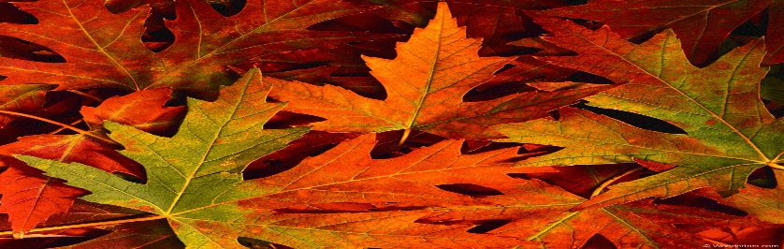
This Photo by Unknown Author is licensed under CC BY-NC-ND

